PROJECT-36
AI Recruitment
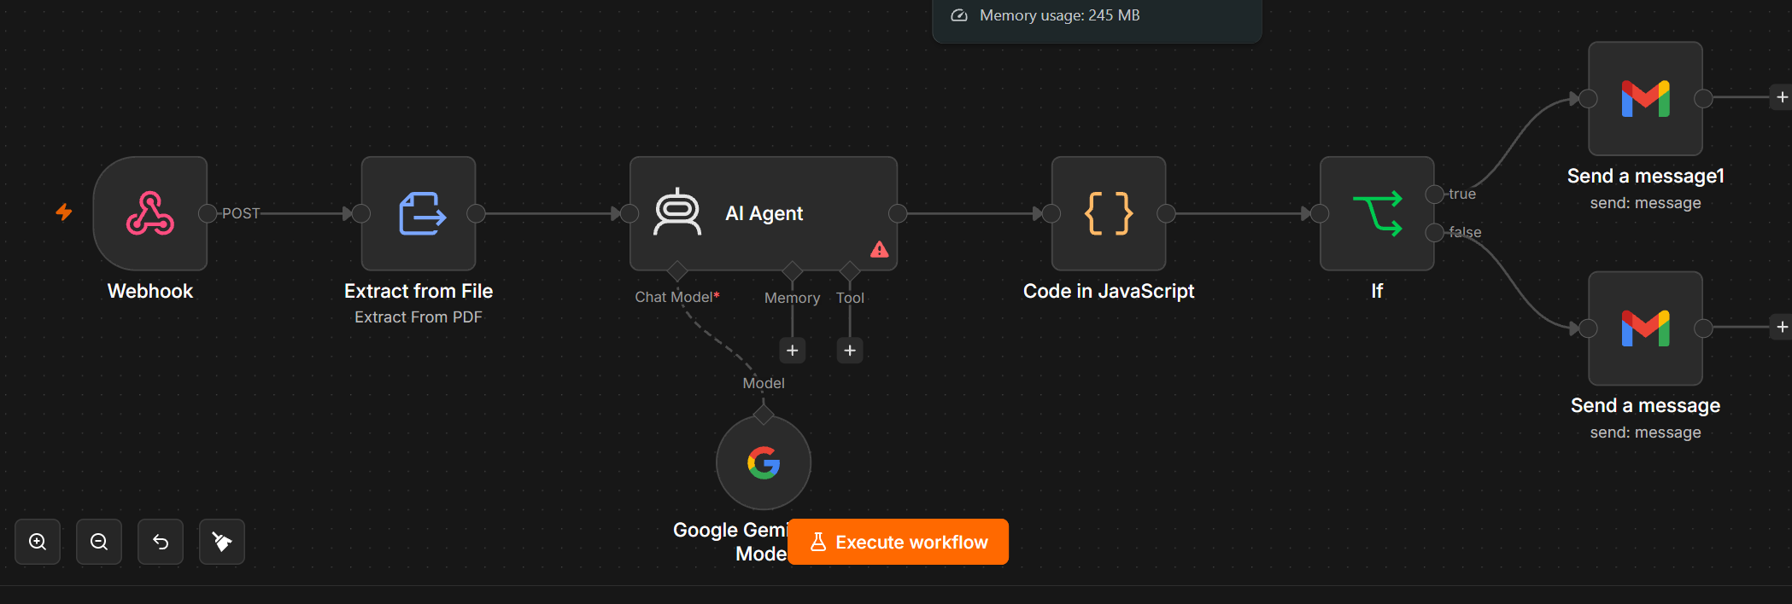
PROMPTS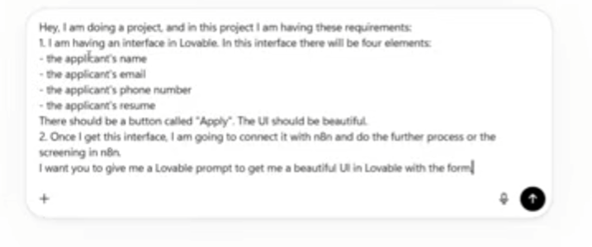
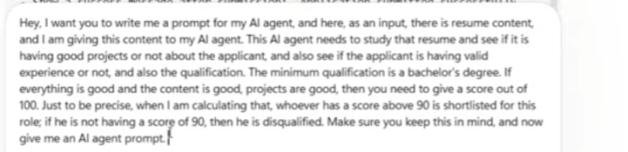

1. Project Title
AI-Powered Resume Screening and Applicant Notification System

2. Project Objective
The purpose of this n8n workflow is to automatically process job applications submitted through a web form, extract the applicant's resume content, analyze the resume using an AI Agent, calculate a score, determine whether the applicant is qualified or disqualified, and send an email notification based on the result.
Main process
Applicant Form → Webhook → Extract Resume → AI Resume Screening → JavaScript Processing → Qualification Check → Email

3. Workflow Architecture
Your workflow contains these main nodes:
┌──────────┐
│ Webhook │
└────┬─────┘
↓
┌──────────────────┐
│ Extract from File│
│ Extract PDF │
└────┬─────────────┘
↓
┌────────────────┐
│ AI Agent │
│ Resume Analysis│
└────┬───────────┘
↓
┌────────────────────┐
│ Code in JavaScript │
│ Process AI Result │
└────┬───────────────┘
↓
┌──────────┐
│ IF │
│ Score>=90│
└───┬───┬──┘
│ │
TRUE FALSE
↓ ↓
┌──────┐ ┌──────┐
│Gmail │ │Gmail │
│Email │ │Email │
└──────┘ └──────┘

4. Node 1 — Webhook
Node Name
Webhook
Purpose
The Webhook is the starting point of the workflow.
Your Lovable application form sends the applicant's information to this webhook.
The applicant submits:
- Applicant Name
- Applicant Email
- Applicant Phone Number
- Resume
HTTP Method
Use:
POST
Expected data
The form should send information similar to:
applicantName
applicantEmail
applicantPhone
resume
The resume should be uploaded as a file/binary value.
Example
Applicant Name: John Smith
Email: john@gmail.com
Phone: 9876543210
Resume: John_Smith_Resume.pdf
The Webhook receives this information and passes it to the next node.

5. Node 2 — Extract from File
Node Name
Extract from File
Operation
Extract From PDF
Purpose
The resume received from the Webhook is a PDF file.
The AI Agent cannot reliably analyze the PDF binary directly, so this node converts the PDF into readable text.
Input
Resume PDF
Output
Something similar to:
John Smith

Education:
Bachelor of Technology in Computer Science

Experience:
Data Analyst Intern - ABC Company

Projects:
Sales Dashboard
Customer Churn Prediction

Skills:
Python
SQL
Power BI
Excel
This extracted text is then provided to the AI Agent.

6. Node 3 — AI Agent
Node Name
AI Agent
Purpose
This is the main intelligence of the workflow.
The AI Agent reads the extracted resume and evaluates the applicant according to your recruitment rules.
The AI Agent should analyze:
- Education
- Bachelor's degree
- Work experience
- Projects
- Technical skills
- Resume relevance
- Overall suitability
- Final score

7. AI Agent System Prompt
Use this as the System Message of the AI Agent:
You are an AI Resume Screening Agent.

Your task is to analyze an applicant's resume and determine whether the applicant qualifies for the job.

Carefully analyze the complete resume provided to you.

Evaluate the following:

1. Education and qualification
2. Bachelor's degree requirement
3. Relevant work experience
4. Projects
5. Technical and professional skills
6. Overall relevance to the job
7. Resume quality

Minimum qualification:

The applicant must have a Bachelor's degree.

If the applicant does not have a Bachelor's degree, the applicant must be marked as DISQUALIFIED.

Scoring system:

Education / Qualification: 20 points
Relevant Work Experience: 25 points
Projects: 25 points
Relevant Skills: 20 points
Overall Resume Relevance: 10 points

Total: 100 points.

Qualification rule:

Score >= 90 = QUALIFIED
Score < 90 = DISQUALIFIED

A missing Bachelor's degree automatically results in DISQUALIFIED, regardless of the score in other categories.

Do not assume information that is not present in the resume.

Do not invent work experience, education, projects, or skills.

Analyze projects carefully. Consider their relevance, technical complexity, description, and usefulness.

Analyze work experience based only on actual experience mentioned in the resume.

Return the result as valid JSON only.

Use exactly this structure:

{
"applicantName": "",
"degree": "",
"bachelorsDegree": true,
"workExperience": "",
"projects": "",
"skills": [],
"educationScore": 0,
"experienceScore": 0,
"projectsScore": 0,
"skillsScore": 0,
"relevanceScore": 0,
"totalScore": 0,
"decision": "QUALIFIED",
"reason": ""
}

Rules:

- totalScore must be between 0 and 100.
- If bachelorsDegree is false, decision must be "DISQUALIFIED".
- If totalScore is below 90, decision must be "DISQUALIFIED".
- Only a score of 90 or above can result in "QUALIFIED".
- Keep the reason concise but specific.
- Return JSON only.

8. Chat Model — Google Gemini
Your screenshot shows:
Google Gemini Model → AI Agent
This provides the AI model that the AI Agent uses to analyze the resume.
Connection
Google Gemini Model
↓
AI Agent
The Gemini model processes the resume text according to the AI Agent's instructions.
Important
Your screenshot shows a red warning icon on the AI Agent.
That usually means there is still something required or incorrectly configured in the AI Agent. Open the AI Agent node and check the highlighted configuration/error before executing the workflow.

9. Memory
You currently have the Memory connection available in the AI Agent.
For resume screening, memory is generally not necessary.
Each applicant should ideally be evaluated independently.
Therefore, you can leave Memory disconnected unless you specifically need conversation history.
For example:
Chat Model → Required
Memory → Optional
Tool → Optional

10. Tools
The AI Agent also has a Tool connection.
For your current resume-screening project, you don't necessarily need additional tools.
The AI Agent can perform the screening directly using the resume text.

11. Node 4 — Code in JavaScript
Purpose
The JavaScript Code node processes the AI Agent's response and prepares a clean value for the IF node.
The main purpose is to extract:
totalScore
decision
applicantName
reason
email
from the AI response.

Recommended JavaScript
If your AI Agent returns the JSON structure shown above, you can use code similar to:
const aiOutput = $json.output;

let result;

try {
result = typeof aiOutput === 'string'
? JSON.parse(aiOutput)
: aiOutput;
} catch (error) {
throw new Error('AI Agent did not return valid JSON.');
}

return [
{
json: {
applicantName: result.applicantName,
degree: result.degree,
bachelorsDegree: result.bachelorsDegree,
totalScore: Number(result.totalScore),
decision: result.decision,
reason: result.reason,
workExperience: result.workExperience,
projects: result.projects,
skills: result.skills
}
}
];
Important
The exact field containing the AI Agent response can vary depending on your n8n configuration.
If your AI output isn't stored in:
$json.output
open the AI Agent's Output and use the actual field name.

12. Node 5 — IF Node
Purpose
The IF node decides which email should be sent.
Your requirement is:
Applicant needs a score of 90 or above to qualify.
Therefore:
Score >= 90
↓
QUALIFIED
and:
Score < 90
↓
DISQUALIFIED

IF Configuration
Set the condition as:
Value 1
Select the score coming from the Code node:
totalScore
Operation
is greater than or equal to
Value 2
90
So the condition becomes:
totalScore >= 90

13. TRUE Branch — Qualified Applicant
The TRUE output of the IF node means:
Score >= 90
The workflow then goes to:
Send a message1 — Gmail
This email should inform the applicant that they successfully passed the initial screening.

14. Qualified Email
Subject
Application Update – You Have Passed the Initial Screening
Email Body
Dear {{$json.applicantName}},

Thank you for applying for the position.

We are pleased to inform you that your resume has successfully passed our initial screening process.

Your screening score is {{$json.totalScore}}/100.

Based on your qualifications, experience, projects, and skills, you have met the minimum requirements for the next stage of the recruitment process.

Our team will contact you with further information regarding the next steps.

Best Regards,
Recruitment Team

15. FALSE Branch — Disqualified Applicant
The FALSE output means:
Score < 90
The workflow then goes to:
Send a message — Gmail
This email informs the applicant that they did not pass the initial screening.

16. Disqualified Email
Subject
Application Update
Email Body
Dear {{$json.applicantName}},

Thank you for applying for the position.

After reviewing your application, we regret to inform you that your application has not passed the initial screening stage.

Your screening score was {{$json.totalScore}}/100.

The minimum qualifying score for this position is 90/100.

Reason:
{{$json.reason}}

We appreciate your interest and wish you success in your future career opportunities.

Best Regards,
Recruitment Team

17. Complete Data Flow
The complete workflow works like this:
Step 1 — Applicant submits form
The applicant fills:
Name
Email
Phone
Resume
↓
Step 2 — Lovable sends data
Lovable sends the application to the n8n Webhook.
↓
Step 3 — Webhook receives application
n8n receives:
Applicant details
+
Resume PDF
↓
Step 4 — Extract PDF
The Extract from File node converts:
PDF → Text
↓
Step 5 — AI Agent
The AI Agent analyzes the resume.
It checks:
Education
Experience
Projects
Skills
Relevance
↓
Step 6 — AI scoring
The AI produces:
Score = 94
or
Score = 82
↓
Step 7 — JavaScript
The Code node extracts the score and decision.
↓
Step 8 — IF
The IF node checks:
Is score >= 90?
↓
Step 9 — Email
If TRUE:
Qualified Email
If FALSE:
Disqualified Email

18. Example — Qualified Applicant
Suppose the resume contains:
Bachelor's Degree: Yes
Experience: 2 years
Projects: 3 relevant projects
Skills: Python, SQL, Power BI, Excel
AI evaluates:
Education: 19/20
Experience: 23/25
Projects: 24/25
Skills: 19/20
Relevance: 9/10

Total = 94/100
IF condition:
94 >= 90
Result:
TRUE
Applicant receives:
Qualified Email

19. Example — Disqualified Applicant
Another applicant gets:
Education: 18/20
Experience: 19/25
Projects: 18/25
Skills: 17/20
Relevance: 8/10

Total = 80/100
IF condition:
80 >= 90
Result:
FALSE
Applicant receives:
Disqualified Email

20. Special Case — No Bachelor's Degree
Suppose an applicant has:
Experience: Excellent
Projects: Excellent
Skills: Excellent
but:
Bachelor's Degree: No
The AI must return:
decision: DISQUALIFIED
Even if the calculated score would otherwise be high.
This is an important business rule.

21. Node Summary
Node | Purpose | Input | Output
Webhook | Receives application | Form data + Resume | Applicant data
Extract from File | Extracts PDF text | Resume PDF | Resume text
AI Agent | Analyzes resume | Resume text | Screening JSON
Google Gemini | AI model | Prompt + resume | AI analysis
Code in JavaScript | Processes AI result | AI JSON | Clean score/data
IF | Checks qualification | Score | TRUE/FALSE
Gmail TRUE | Qualified notification | Applicant data | Qualified email
Gmail FALSE | Rejection notification | Applicant data | Disqualified email

22. Final Workflow
Your final n8n workflow should look like:
WEB FORM / LOVABLE
│
▼
WEBHOOK
│
▼
EXTRACT FROM FILE
Extract PDF
│
▼
AI AGENT
│
│
Google Gemini
│
▼
CODE - JAVASCRIPT
│
▼
IF
Score >= 90?
/ \
YES NO
│ │
▼ ▼
GMAIL GMAIL
Qualified Disqualified
Email Email
23. Project Outcome
This workflow creates an automated AI Resume Screening System that reduces manual resume screening.
The system automatically:
- Receives applications
- Extracts resume information
- Uses AI to analyze candidates
- Checks Bachelor's degree
- Evaluates experience
- Evaluates projects
- Evaluates skills
- Generates a score out of 100
- Applies the 90-point qualification threshold
- Sends the appropriate email automatically
Key business rule:
90 or above = Qualified
Below 90 = Disqualified
No Bachelor's degree = Automatically Disqualified

